

**IRIS Newsletter 2nd Quarter 2013 Volume 21, Issue 2**

**Iowa Radio Reading Information Service**

**For the Blind and Print Handicapped, Inc.**

**YOUR 24-hour Radio Reading Service!**

Jerry Wickersham and Senator Dick Dearden (District 34).

Maryfrances and Senator Pam Jochum (District 14).

New IRIS listener Penne Jackson and Rep. Anessa Kajtazovich (District 21).

(Waterlooo)

Deb Caldbeck, Shannon Brown, Mary Ann Nielsen, Maryfrances, Rob Davis, Joan and Delores Caldbeck

watch Governor Branstad sign the proclamation.

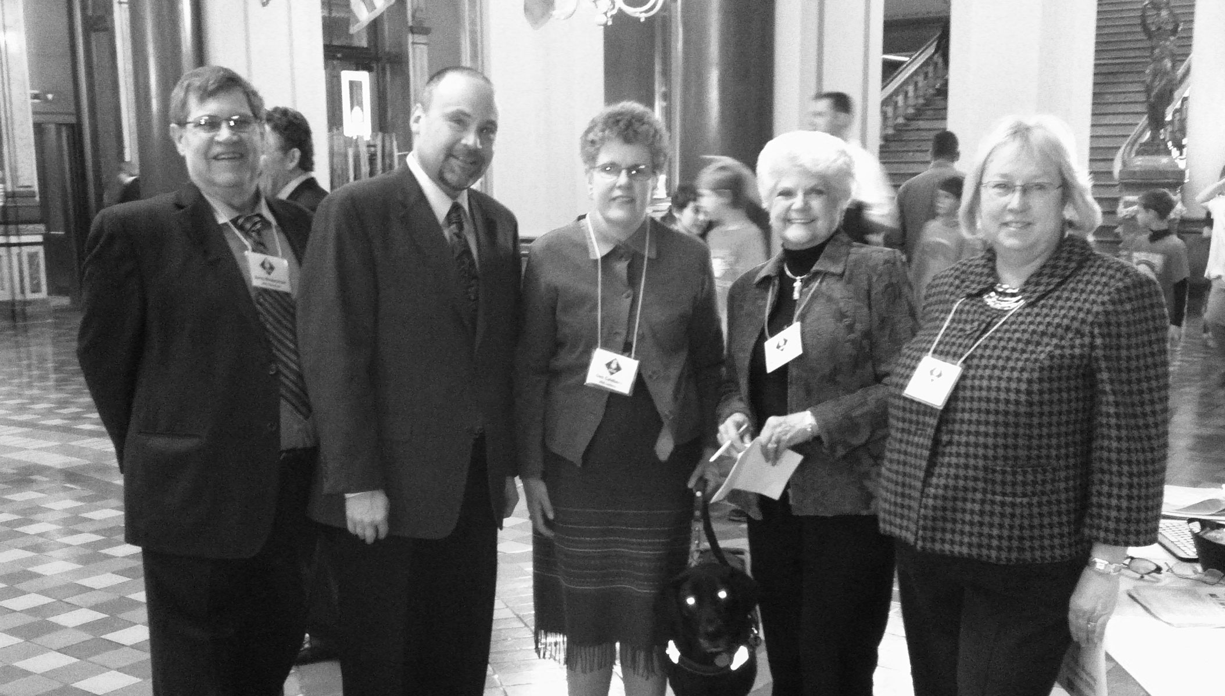

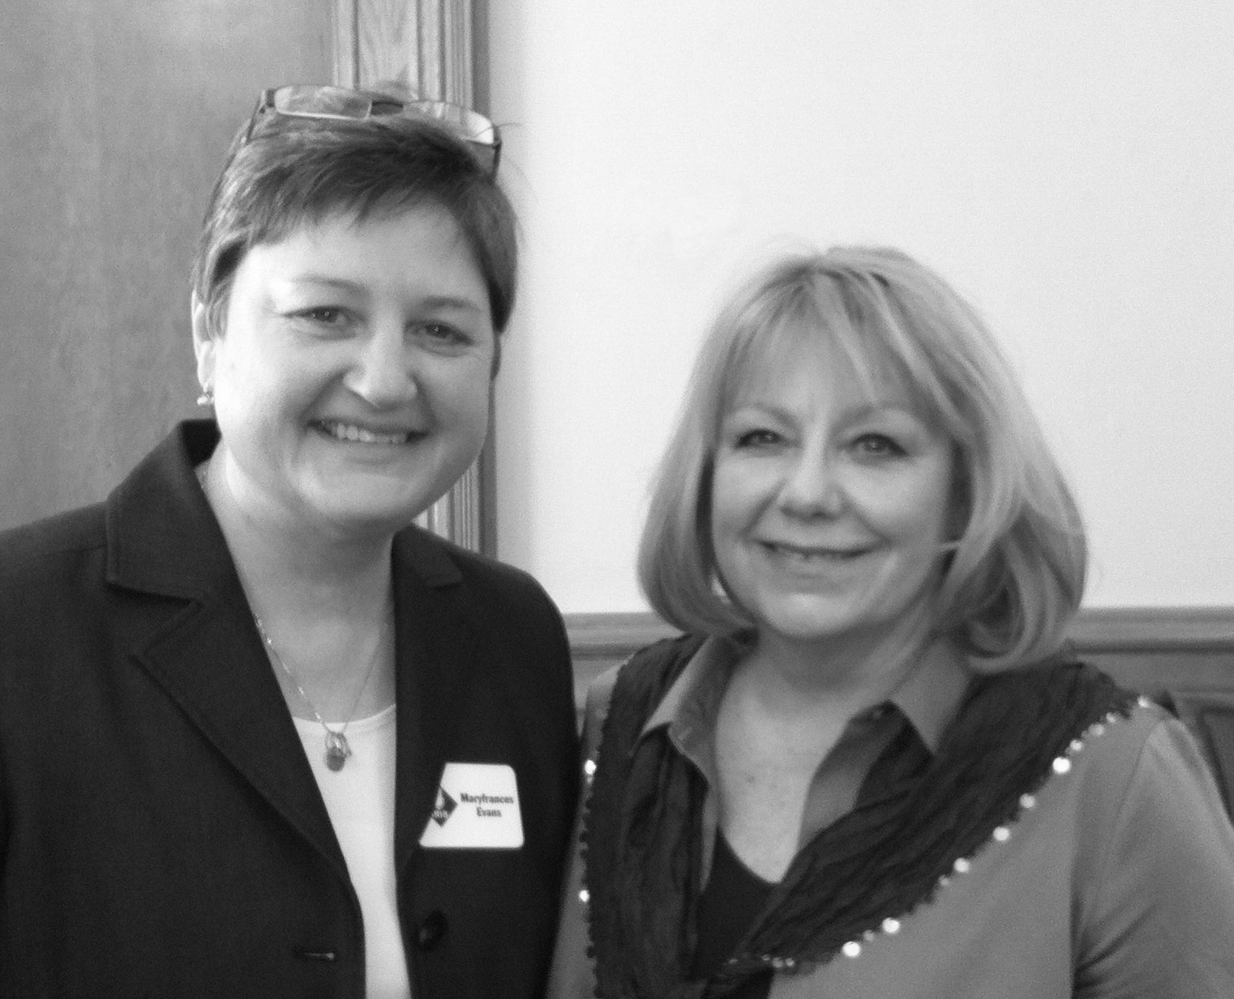

Sen. Janet Petersen (District 18) talks with a student from

the Iowa Dept. for the Blind.

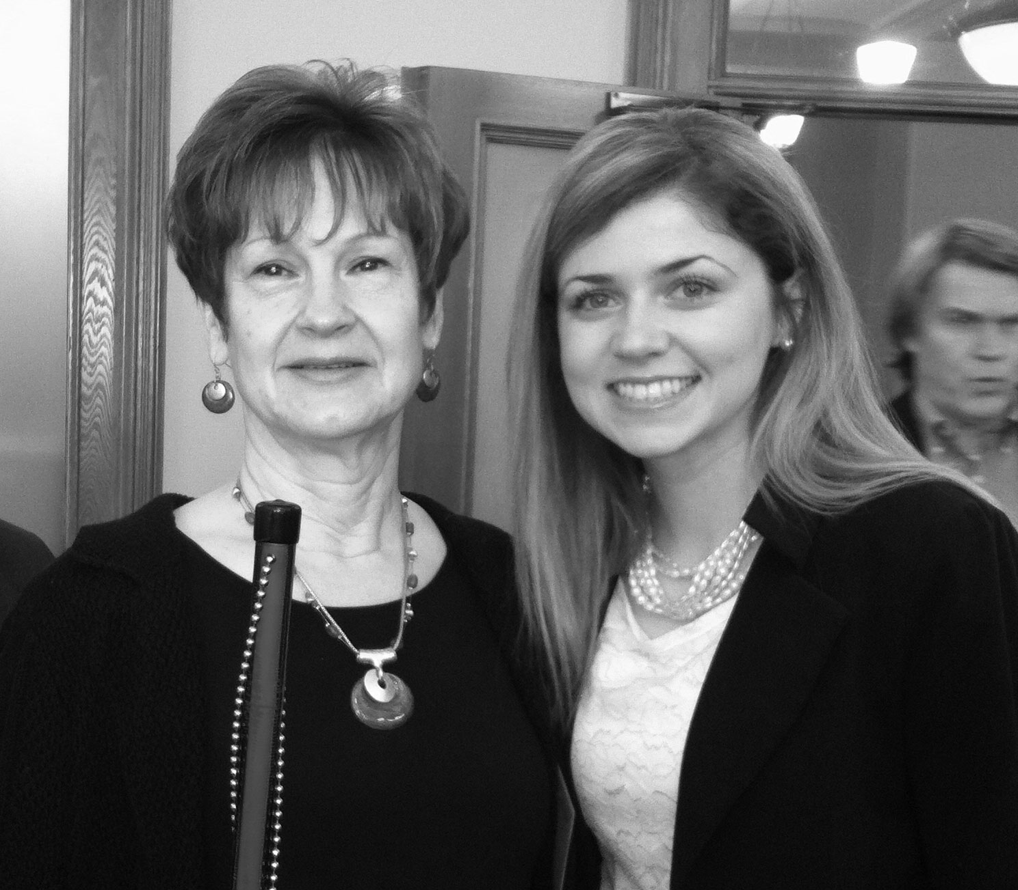

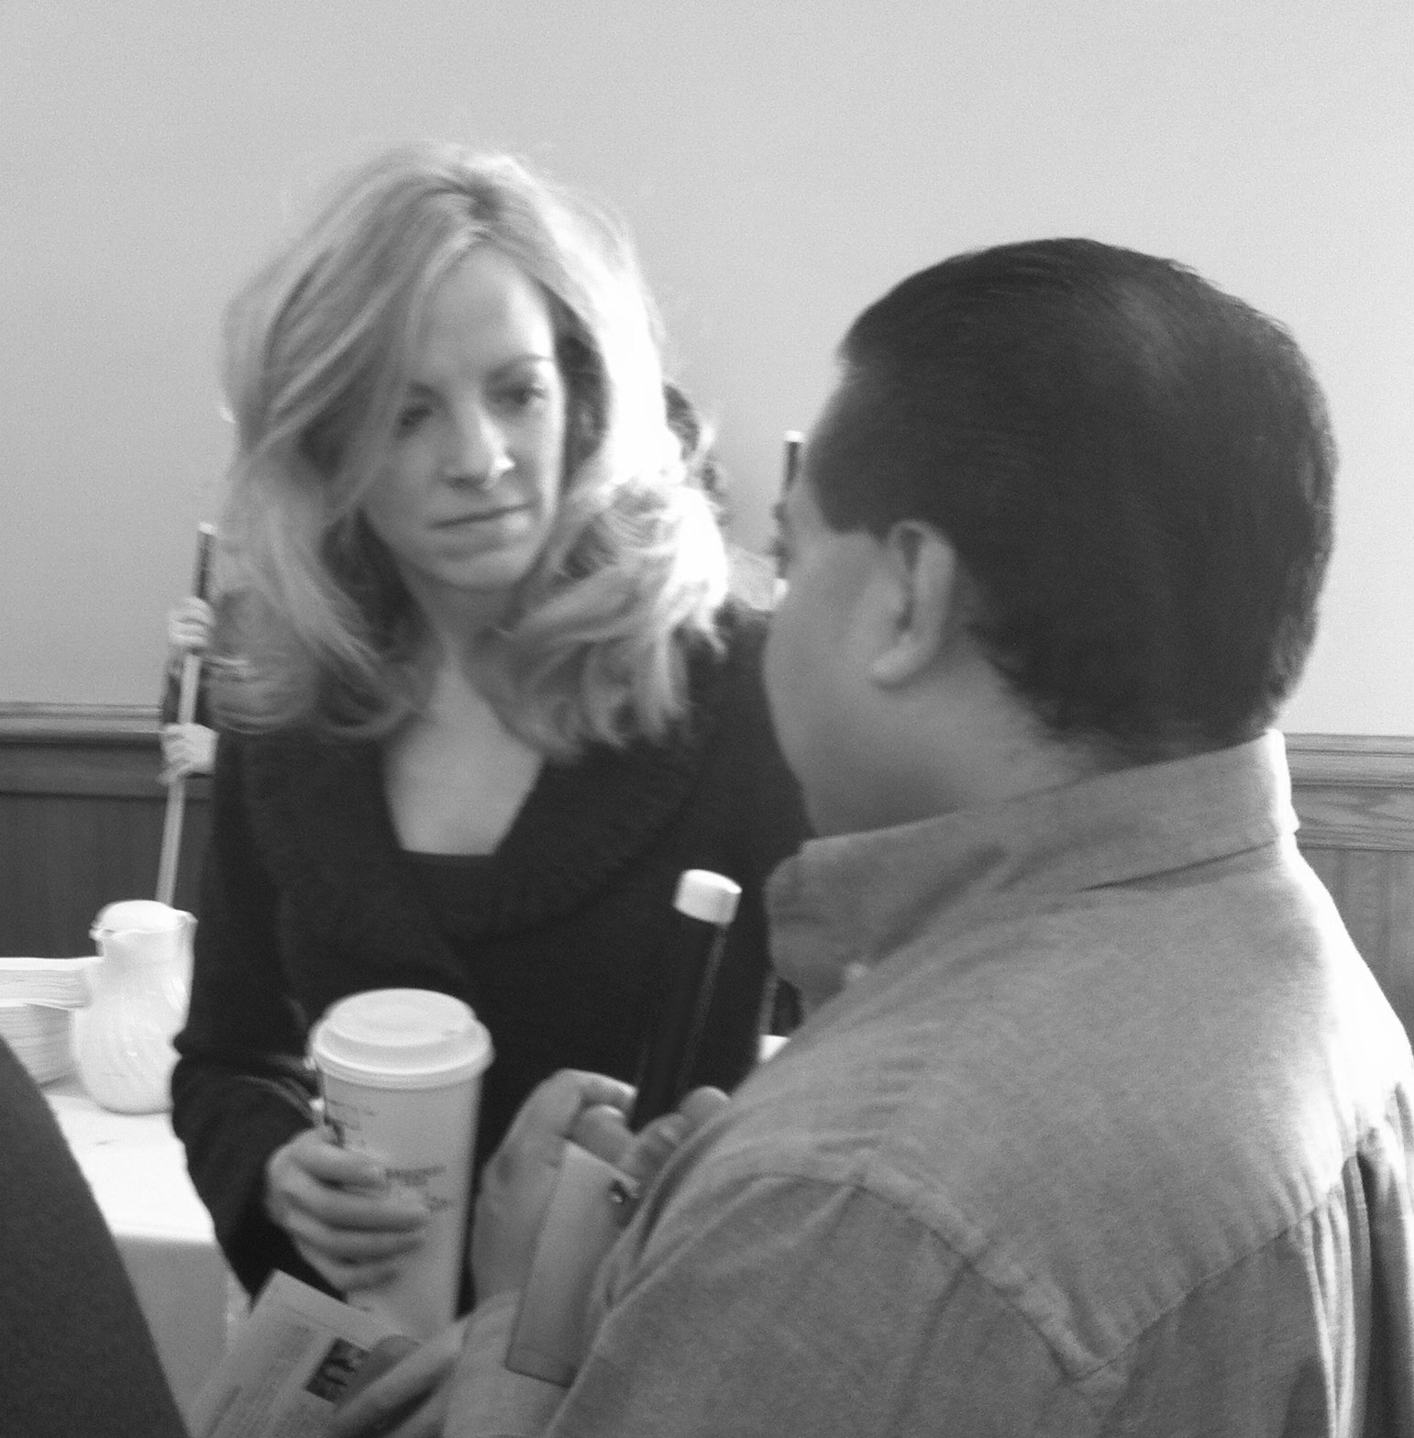

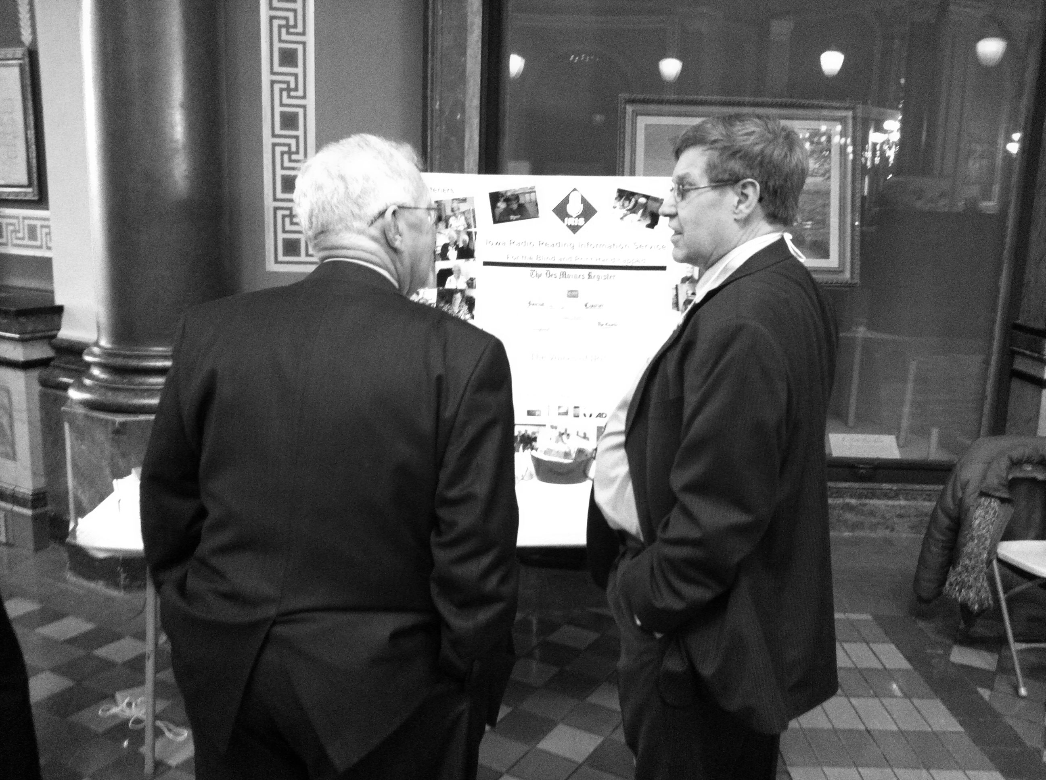

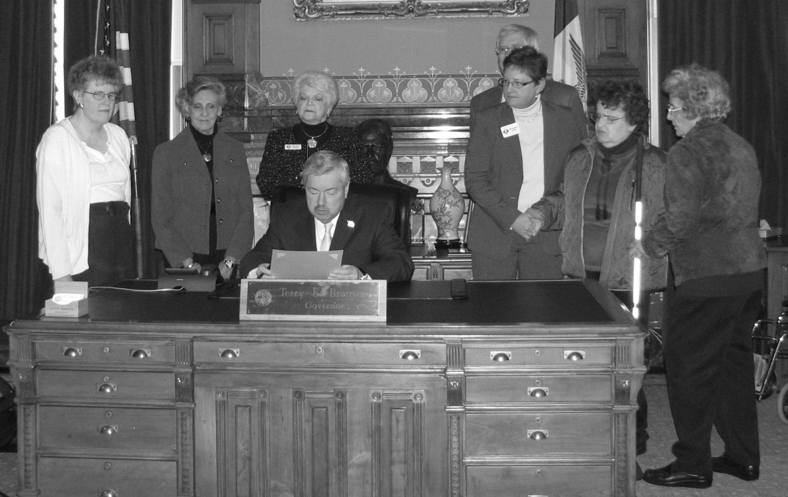

**IRIS Ice Cream Social – August 22nd!**

Join us Thursday, August 22nd from 4 to 6pm at our Park Fair Mall studios. We’ll enjoy treats, friends, and our IRIS awards. This year, the Ice Cream Social marks the beginning of our Silver Anniversary Year! If you would like to attend, please let us know at 243-6833. Transportation for listeners in the Des Moines area is available at no cost – thanks to our fantastic volunteers! If you need transportation, be sure to mention that when you call to RSVP.

**IRIS on Capitol Hill!**

February 19, IRIS took part in Volunteer Awareness Day. March 6 was Voices of IRIS Day across Iowa. We were honored to receive a proclamation from Governor Branstad recognizing the work of our volunteers. That afternoon, IRIS hosted a reception for legislators to meet IRIS volunteers and learn more about our work across the State. March 27, IRIS hosted a table at the Iowa Department for the Blind’s Legislative Breakfast. Our thanks to all the legislators and staffers who stopped by one of these events to support IRIS!

Jerry Wickersham, Jim Obradovich, Deb Caldbeck, Mary Ann Nielsen and Julie Gold.

**Dorothy H. Kirsner – May 3, 1919 – May 20, 2013**

Thousands of IRIS listeners and volunteers have

lost a precious friend. Dorothy H. Kirsner was

one of the founders of IRIS and an amazing person.

She was out-going, direct, diligent, and dedicated

to solving problems, Dorothy was also fun loving,

stylish, amazingly energetic, and a great friend. She

always found a way to help anyone - no matter what

the need.

Dorothy was best known for her efforts on behalf of the blind since the early 1940s. Through the Temple B'nai Jeshurun Sisterhood, she became a certified Braillist helping transcribe countless volumes of reading material. At that time, this required becoming certified by the Library of Congress and transcribing each book to Braille by hand – page by page. Certified Braillists were considered to be so valuable that Dorothy's certificate of capability was signed by then President of the United States, Franklin D. Roosevelt.

In June of 1957, Dorothy was appointed by the Governor of Iowa to the Iowa Commission for the Blind and was elected chair at her first board meeting. She was tireless in her dedication, including ensuring the purchase of the building that houses the Iowa Department for the Blind today. In 1966, a conference room there was formally named the Dorothy Kirsner Conference Room to recognize her contribution to the Commission's success.  
 Dorothy was instrumental in bringing Kenneth Jernigan to the Commission who, as their director, implemented innovative vocational rehabilitation programs. In 1968 Jernigan was given an award from the President of the United States whose representative stated, "If a person must be blind, it is better to be blind in Iowa than in any other place in the nation, or the world!"

She helped blind children like Deb Caldbeck mainstream into the Des Moines Public Schools, transcribing Deb’s text books from Kindergarten through her high school graduation. “If it weren’t for Dorothy, I would not be where I am today”, said Deb. “She made success just as possible for me as for any sighted kid.” Dorothy was an education aide to blind children at Smouse School, participating in orientation classes for parents and teachers. With her friend, Sis Stein, she organized prisoners at the Fort Madison Penitentiary to record and transcribe books into Braille.

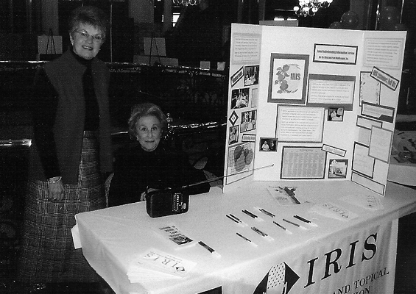 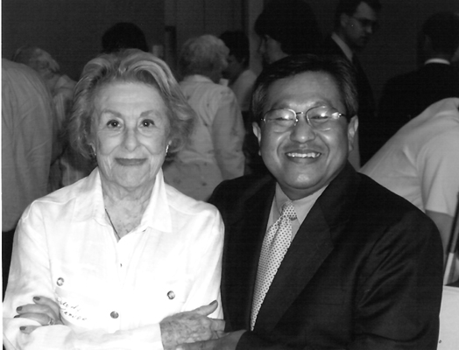 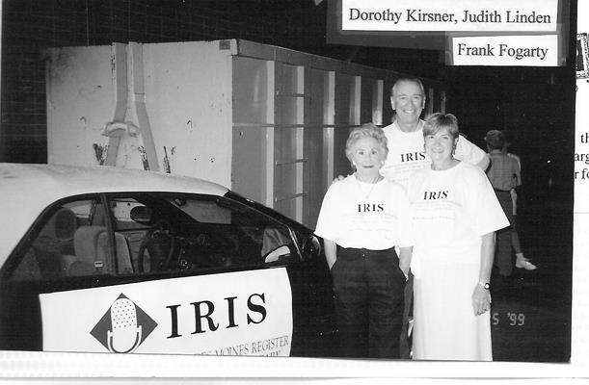

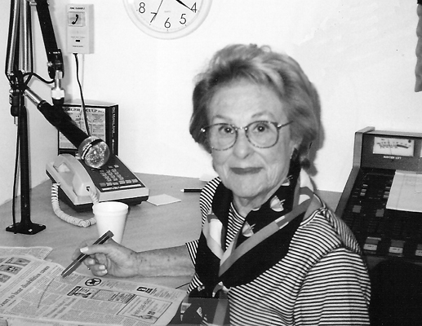

**The Dorothy Kirsner Award 2011:**

IRIS Chair Mary Ann Nielsen, Senator Tom Harkin, Dorothy Kirsner, Maryfrances,

And Iowa Department for the Blind Director Karen Keninger.

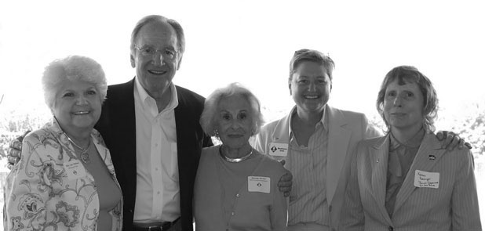

When IRIS was founded in 1989, Dorothy was there.

Her dedication to our listeners and volunteers continued

for more than 20 years.

In 2010, IRIS established the Dorothy Kirsner award,

an honor presented jointly by IRIS and the Iowa

Department for the Blind, to recognize individuals and

organizations who have made an outstanding and lasting

impact on the lives of Iowans who live with blindness or

visual impairments. Fittingly, the first recipient was

Dorothy herself. In 2011, the award was presented to

Senator Tom Harkin and to Iowa Public Radio in 2012.

Mr. James Carney wrote, “I read with great sadness about the passing of Dorothy Kirsner. Mrs. Kirsner was a beautiful woman who, as you know, did many wonderful things. One very dear to my heart was her involvement with the Iowa Radio Reading Information Service for the Blind. My mother was blind and your service was of great help to her. I always admired Mrs. Kirsner’s efforts on behalf of the blind. We’ve lost a great woman.”

IRIS simply would not exist without the treasure and champion that was Dorothy Kirsner. Every day of the year, thousands of listeners with low or no vision get the same access to print information as their sighted neighbors – because of Dorothy. We have been so lucky. For over seventy years, the quiet efforts of one extraordinary person have changed so many lives for the better.

Our thoughts remain with Dorothy’s husband of 72 years, Alvin, her sons, James, Richard and Lawrence and the entire Kirsner family.

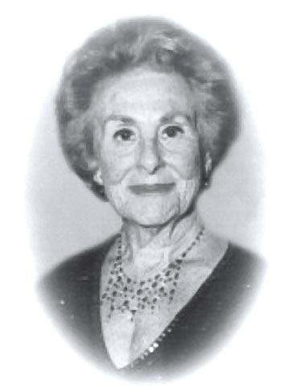

**Celebrate IRIS 2013!**

In April, we held our second annual Celebrate IRIS event. This year’s program included a live audio description demonstration. Our team described two pieces of art – one a painting created by IRIS listener Elsie Monthei. A highlight was a live described performance by Ballet Des Moines. Dancers presented an excerpt from their production of Snow White. A live auction and raffle raised over $1,500 for IRIS and the games ensured that lots of folks walked away with a prize or a cake. Our thanks to everyone who helped make this event a success!

**Letters from Our Friends:**

“As I go back several years now I can recall the first radio program which was operated out of the Iowa Department for the Blind. This was a program recorded at the Department by Darrell Powers. The radio program was broadcast over KDPS, a low-power signal station in Central Iowa. It is breathtaking to think that we now have a 24/7 radio reading service not only in Des Moines but statewide. Your service also features numerous local papers including the Fort Dodge, Mason City, Cedar Rapids and Waterloo papers. This is wonderful access for our blind brothers and sisters.

I am writing to thank you for your efforts on behalf of all blind and severely visually impaired Iowans. I particularly want to express my appreciation for your work in the area of live real-time audio description. As you know, my wife and I attended the Ballet Des Moines event in early April at the Des Moines Civic Center. I enjoyed the audio description.

I also want to thank the readers, all volunteers and board who support Iowa Radio Reading Services. Without the hard work of all the volunteers, Iowa Radio Reading Services would not be able to help the literally thousands of Iowans who depend on your service every day.

It is exciting to hear about all of the great projects underway at IRIS. We look forward to even more from IRIS.

*Frank Strong, Jr.*

*President – Iowa Council of the United Blind*

“I am truly appreciative of the work IRIS and the Des Moines Civic Center have done in making audio described Broadway shows available to those of us who are blind. I’ve always loved theatre, but when I went blind I lost a lot of what was going on during a show. But by having live describers, I am able to more fully appreciate the show. It’s great to laugh with the rest of the audience and actually know why I’m laughing. The describers do a fantastic job, and I intend to see more described performances in the future.”

*Norma A. Boge*

**Out and About**

IRIS hit the road to participate in Vision Loss Resource Fairs in Muscatine and Fairfield. Presented by the Iowa Department for the Blind, these events showcase devices and services available to folks living with vision loss. It was great to visit with so many folks from the area and we enrolled eight new listeners for IRIS services!

**A BIG THANK YOU to Our Friends in Northeast Iowa**!

For years, IRIS was supported by federal funding. Though requests for our services continue to increase, those dollars are no longer available. As a statewide service, we’ve begun to reach out for support from the communities we serve. We are thrilled that our outreach is beginning to show results. We received financial support from the

Community Foundations of Kossuth County, Chickasaw County and Franklin County!

**Drop us a Line!**

All of us at IRIS love to hear from our listeners and listener families. If you have a comment, question or concern, please give us a call at 515-243-6833 or toll-free from anywhere in Iowa at 1-877-404-4747.

If you would like to be added to our email list, please call to share your email address. You can also sign up for our mailing list on our website iowaradioreading.org.

**Take IRIS With You!**

Did you know that you can listen to IRIS on your computer, smartphone, iPhone or tablet? At iowaradioreading.org, you can hear recordings of your favorite sections of the newspaper or access 24/7 programs live on our webstream.

If you use a mobile telephone or device, simply download the free iBlink Radio app from Serotek. Scroll down to Reading Services and select Iowa Radio Reading Service. As with all IRIS equipment and services, mobile access is provided at no cost to you. Our thanks to the Iowa Department for the Blind for making mobile access to information available to our listeners.



Thelma Miller

Gene & Wanda Neese

R.L. & Margaret Nelson

Edward & Della Owens

Sally Pedersen

Ned & Ruth Ratekin

Ron & Susy Rosenblatt

William Sanders

Dave & Jeanette Saurman

Pat Selburg-Smith

Marjorie Shuey

Wilbur Tiffany

Cecilia Tomlonovic

Karen Witzke

Mildred Keller

Mary & Dan Kelly

Leon Koster

Lakeside Hotel & Casino

Roger Larson

Janithe Lewis

Carol & Fred Lockard

Doris & L.R. Lowell

Thomas & Dorothy McGee

Patrick McNulty & Mary Kundrat

Laura McVay

Bob & Sharon Meisenheimer

Meredith Corporation Foundation

FirstGiving/IndieGoGo

FISERV Corporation

Marylynn Gillingham

Tim Gracey

Dr. John & Irene Graether

Geoffrey Graham

Leland Halling

Michael & Constance Hancock

T.R. & N.S. Harrison

Delpha Holtzman

Jack & Carole Horowitz

Marian Jacobs

Lois & Steven Jennings

Virginia Johnson

Robert Josten

Elvin & Norma Albertson

Violet M. Baker

Joseph Behrendt

Arlis Black

Karen Blunt

Linda Brown

Shannon Brown

Donald & Carol Carlson

Robert Clayton

George & Patricia Davison

Marilyn & W.C. Davison

Joanne Dixson

Joyce Domeyer

Lucille Dunlavy

Donald & Martha Eddy

Dale Finnegan

