Iowa Radio Reading Information Service
For the Blind and Print Handicapped, Inc.

IRIS – Your 24-hour Radio Reading Service!
IRIS Newsletter – Winter 2012

Welcome 2012!
We are excited for the year ahead. From programming to fundraising, IRIS is committed to maintaining and improving our services for you in 2012.
Thank You !
We heard from a number of our listeners after our last newsletter. Your contribution – no matter how large or small – keeps us on the air for you. Even better, some of you sent comments along to us:
“I listen to IRIS every night and enjoy it so much. Thank you.”
“Thank you for the work you do.”
“Please accept this small donation. I listen to IRIS every morning.”
“Thank you for the use of the radio. Connie enjoyed listening every day.”
“Thank you for the good service. I hear the Fort Dodge Messenger every morning.”
“I am so happy to be able to have this radio. I will be listening more and more and I enjoy listening to the Waterloo Courier. Thank you all.”
IRIS loves to hear from YOU, please drop us a line any time.
Technically Speaking -
IRIS operates reading studios in seven locations – resulting in lots of places for things to break down. Thanks to a lightning strike in Fort Dodge, we have been struggling with technical problems there. An amazing donation from Fort Dodge listener Roger Larson appeared, and we were able to purchase new equipment that put our signal back and better than ever! Our thanks to Roger, Friendship Haven and the WOI engineers who worked together to fix and improve our service to our Fort Dodge listeners!

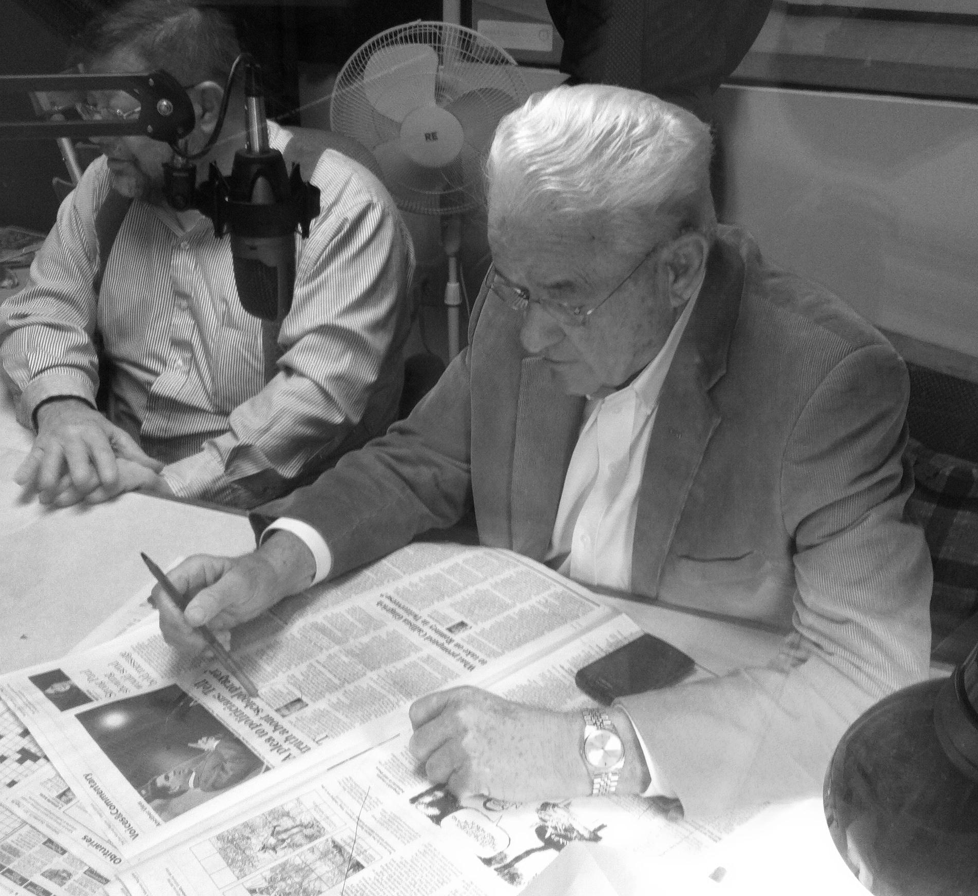

Congressman Boswell Reads on IRIS -
December 21st, IRIS listeners got a special treat when Congressman Leonard Boswell visited our studios. Representative Boswell took a turn at the microphone and visited with volunteers and staff. Thank you, Congressman for your continued support of IRIS!

Here is our updated Program Schedule – Effective January 1, 2012

MONDAY
Midnight – American Past
1am – Commentary
6am – Cover to Cover
7am – Wall Street Journal
8am – Local Papers/Disability Topics
9am – Des Moines Register
Noon – Pet Hour
1pm – Old Friends
2pm – New York Times
3pm – World Safari
4pm – Iowa Salute
5pm – Ames Tribune/CB Nonpareil
6pm – Des Moines Register
9pm – 50 Something
9:30pm – Business Record
10pm – Cityview
11pm – Ames Tribune
TUESDAY
Midnight – Business Commentary
1am – Business Week
2am – World Safari
3am – Money Matters
4am – Diabetes News
5am – NY Times Book Reviews
6am – People’s Pharmacy
7am – Wall Street Journal
8am – Local Papers/Diabetes News
9am – Des Moines Register
Noon – People
1pm – In the Kitchen
2pm – New York Times
3pm – National Geographic
4pm – Access Iowa
5pm – Ames Tribune/CB Nonpareil
6pm – Des Moines Register
9pm – Magazine Picks
10pm – Readers Digest
11pm – Ames Tribune
WEDNESDAY
Midnight – Blind Handyman
1am – Rolling Stone
2am – Sports Illustrated
3am – Old Friends
4am – New Yorker
5am – Mother Earth
6am – In Focus
7am – Wall Street Journal
8am – Local Papers/In the Kitchen
9am – DM Register
Noon – Midweek Shopping Cart
1pm – At Home
2pm – New York Times
3pm – Oprah
3:30pm – Catalogs
4pm – Cityview
5pm – Ames Tribune/CB Nonpareil
6pm – Des Moines Register
9pm – Midweek Shopping Cart
10pm – Mother Earth
11pm – Ames Tribune
THURSDAY
Midnight – Old Friends
1am – Good Old Days
2am – It Makes a Difference
3am – Disability Topics
4am – Money Matters
5am – National Enquirer
6am – People’s Pharmacy
7am – Wall Street Journal
8am – Local Papers/Personal World
9am – Des Moines Register
Noon – Consumer Advocate
1pm – Time Magazine
2pm – New York Times
3pm – Smithsonian
4pm – Midweek Shopping Cart
5pm – Ames Tribune/CB Nonpareil
(THURSDAY CONTINUED)
6pm – Des Moines Register
9pm – Midweek Shopping Cart
10pm – Mother Earth
11pm – Ames Tribune
FRIDAY
Midnight – Multicultural Press
1am – People
2am – Apple a Day
3am – To Your Health
4am – Time
5am – Money Matters
6am – 50 Something
6:30am – Business Record
7am – Wall Street Journal
8am – Local Papers/Personal World
9am – Des Moines Register
Noon – Readers Digest
1pm – To Your Health
2pm – New York Times
3pm – Pet Hour
4pm – Cover to Cover
5pm – Ames Tribune/CB Nonpareil
6pm – Des Moines Register
9pm – Sports Illustrated
10pm – Newsweek
11pm – Ames Tribune
SATURDAY
Midnight – Apple a Day
1am – Time
2am – Nothing but the Truth
3am – New Yorker
4am – Newsweek
5am – Consumer Advocate
6am – Oprah
6:30am - Catalogs
7am – Science Hour
8am – Iowa Salute
9am – Des Moines Register
Noon – Multicultural Press
1pm – Your Personal World
2pm – Money Matters
3pm – Apple a Day
4pm – In Focus
5pm – Ames Tribune
6pm – Des Moines Register
9pm – Blind Handyman
10pm – Nothing but the Truth
11pm – American Past
SUNDAY
Midnight – Cover to Cover
1am – Wall Street Journal
2am – Smithsonian
3am – Business Commentary
4am – Multicultural Press
5am – Inner Life
6am – Time
7am – Polk County Senior
7:30am – AARP Report
8am – Local Papers/Business Week
9am – Des Moines Register
1pm – Magazine Picks
2pm – Bookcase
3pm – Art Fare
4pm – Polk County Senior
4:30pm – AARP Report
5pm – DM Register
9pm – It Makes a Difference
10pm – People’s Pharmacy
11pm – Cityview

Hear our schedule each day at 7:58am. Schedules can be sent to you in braille, large print or audio formats. Just call 1-800-404-4747.

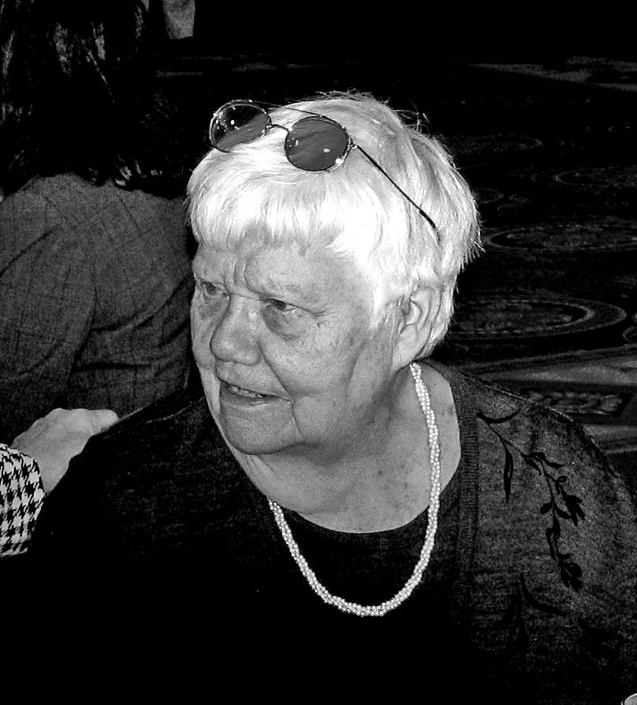
Listener Spotlight: Kirsten Christanson
Kirsten was diagnosed with macular degeneration three years ago and has been tuned into IRIS ever since!
“My favorite program is the Des Moines Register – I listen to it faithfully every day. I can still read the newspaper with a magnifying glass, but I love listening to it on IRIS.”
Fun Fact: Kirsten was born in Denmark, but has called Des Moines home since 1953.

The Reverend Canon William L. Jacobs –
IRIS lost a dear friend and longtime champion for our service in late November. Reverend Bill was a devoted IRIS volunteer who served as a reader for many years – and most recently served on the IRIS Board of Directors. Our thoughts are with his family as we thank them for sharing such an amazing person with IRIS. Reverend Bill was 94 years old.
IRIS FACT: 3,000 Hours = 125 Days of Reading
The power of IRIS comes from the voices of our volunteers. More than 300 strong, these dedicated folks make sure that YOU have equal access to print information. In 2011, IRIS volunteers produced more than 3,000 hours of spoken material – both live and recorded.
The VOICES of IRIS –
One of our most popular programs is The Midweek Shopping Cart. Each week, you hear the latest ads and specials from grocery, discount and department stores. The voices of The Cart are longtime IRIS volunteers Marlys Van Hauen and Deb Headington. We are so grateful for their continued dedication – Thank you Marlys and Deb!
Do you have an email address?
If you would like to be on our electronic mailing list, please give us a call and share your email address. 515-243-6833 or toll-free 1-877-404-4747.
THANK YOU Sally Vander Linden and Jo Slayton –
The IRIS Board of Directors is losing two amazing women. Sally has worn so many hats in our organization for years. As an IRIS volunteer, board member and executive director, Sally’s voice and influence have been fixtures for so many years. Jo has been an avid IRIS listener and fan since the beginning. We have relied on her guidance time and again. All of us at IRIS send our best wishes and gratitude to Sally and Jo.

Around the Office –
Meet Jim Boyd – the new Operations Coordinator for IRIS. You might be familiar with Jim from some of our weekend programs. Jim joined IRIS last March as our weekend producer. In October, Jim was promoted to his new position. Radio Reading is in Jim’s blood. While in college, Jim helped a blind student at Grand View University – reading texts aloud, helping with tests and recording assignment to tape for her. After graduate school, Jim joined the folks at the Kansas Audio Reader as their telephone reader supervisor. We were thrilled when Jim moved back to Iowa and darkened our door as a volunteer in 2010. It has been a perfect fit ever since. If you need anything at all, please give Jim a call.
IRIS in Your Pocket –
You can use your smart phone or other mobile device to access the live IRIS signal wherever you go. Just download the free iBlink Radio application from SamNet. Choose “Reading Services”, then “Iowa Reading Information Service” to listen to IRIS on mobile device! The application is now available for both iPhone and Droid platforms.
Follow IRIS on Twitter or Facebook –
If social media is your thing, you can keep tabs on IRIS on Facebook – just do a search for Iowa Radio Reading. On Twitter, you can find us at IRIS_DSM.
Remember IRIS –
Memorial Gifts –
IRIS has been privileged to be named the recipient of memorials in 2011. We are so grateful for this kind of support and humbly accept these memorial gifts. From bequests to memorials, including IRIS in your final plans ensures the voices of IRIS can continue for others. If you would like to find out more about how to include IRIS in your final planning, we would be happy to help you. Just give us a call at 243-6833 or 1-877-404-4747.
IRIS Makes it Easy –
We’re now equipped to accept donations from your credit or debit card. You can make a donation on our website or simply call our office and we can process your donation over the phone.
And finally -
Though we work closely with Iowa Public Radio, Iowa Public Television and the Iowa Department for the Blind, IRIS remains an independent non-profit organization – relying solely on contributions. We are so proud that we continue to provide our services and equipment at no cost to our listeners. In order to sustain our mission, we must constantly seek the financial support needed to keep the voices of IRIS on the air for you. If you or your loved ones value what we do each day, let us know – and we thank you.
“My radio is very much appreciated. I use it mostly at night as I awaken often and it is there to listen to some interesting programs. I enjoy hearing your readers.”
Marie D. – Sioux City listener in Nebraska

100 East Euclid Ave., Suite 117
Des Moines, Iowa 50313

Free Matter for the Blind
And Physically Handicapped
Iowa Radio Reading Information Service
For the Blind and Print Handicapped, Inc.

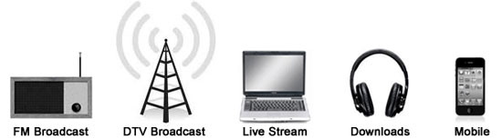
IRIS Delivers ACCESS to Information: On the Air, On your Mobile Device, and On the Web

www.iowaradioreading.org 515-243-6833 1-877-404-4747

Board of Directors:

Mary Ann Nielsen, Chair
Patrick McNulty, Vice-Chair
See Rodari, Treasurer
Catherine Witte, Secretary
Chip Albright
Mollie Cooney
Becky Cox
Julie Gold
Susan Kimelman
Diane Boatwright
Ron Rosenblatt
Sally Vander Linden
Jo Ann Slayton
Rob Davis
Dennis Crabtree
Bonnie Whitson
Staff:
Maryfrances Evans
Jim Boyd
Jeni Rector

